|  |  |
| --- | --- |
| **DATE** | 8 november 2022 |
| **TEAM ID** | PNT2022TMID29109 |
| **PROJECT NAME** | Real-Time Communication System powered by AI for Specially  Abled |

Data Collection

25 September 2022

PNT2022TMID41036

**Create Train And Folders**

Conversation engine for deaf and dump:

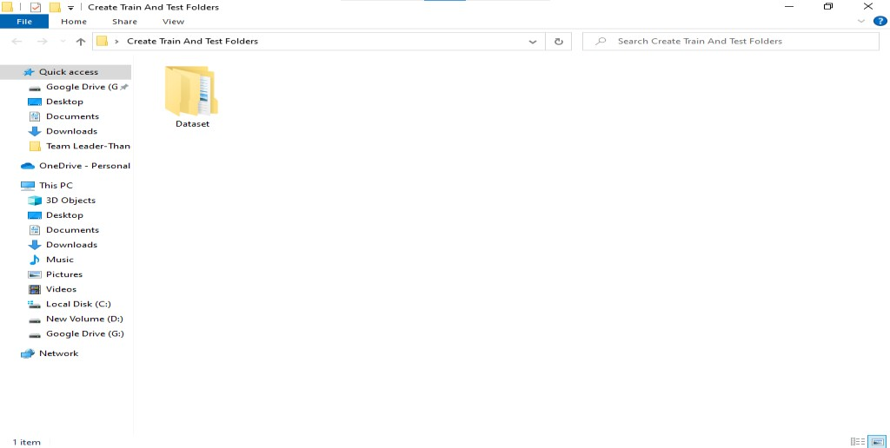

Dataset:

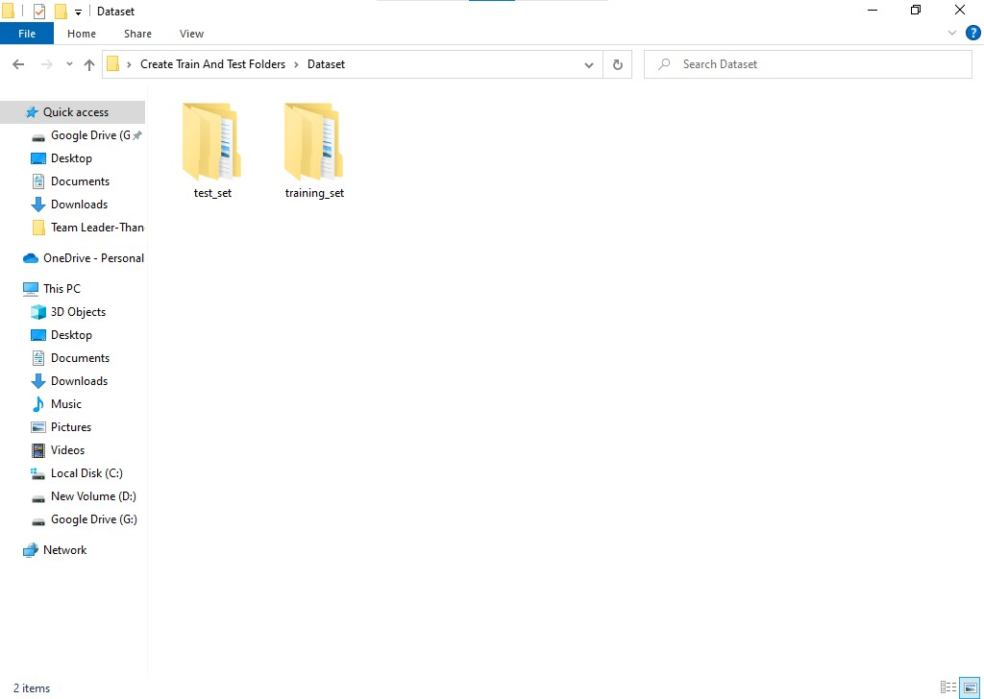

**Test set:**

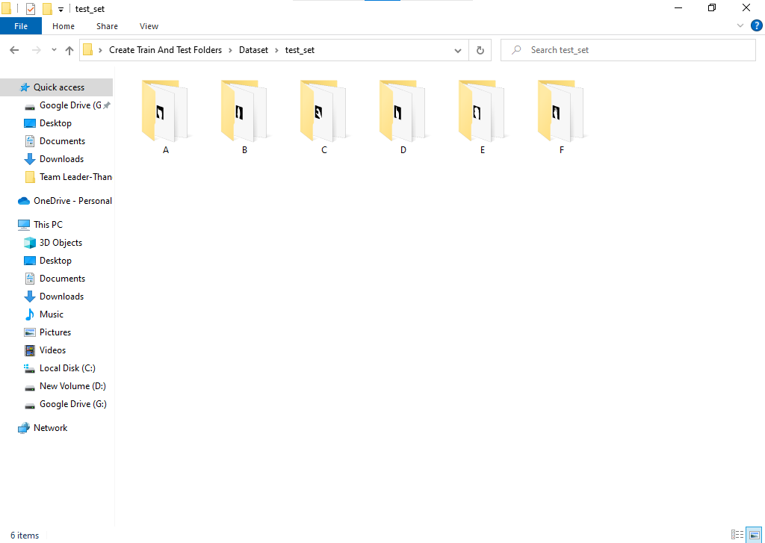

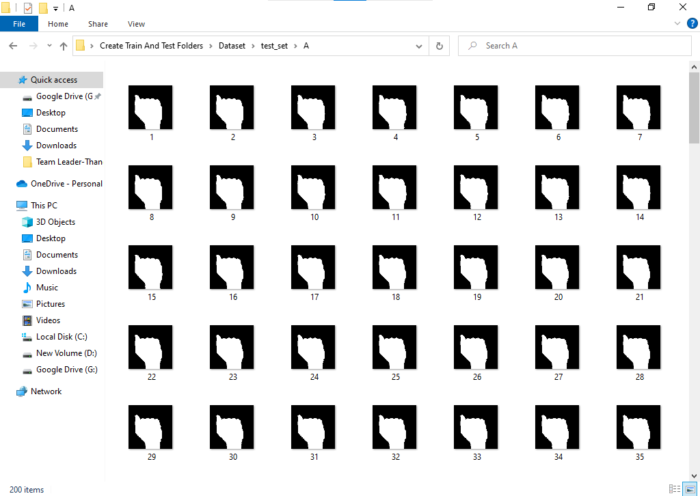

**Training set:**

